# GLA University

# Mathura – 28140 INDIA 2022

###### Mini Project Project: CAKE BUFFET

# CUSTOMIZE CAKE ORDERING

# WEB APPLICATION

# 

# Submitted by

**Name University Roll No:**

|  |  |
| --- | --- |
| 1) Rahul Kumar Jha |  |
| 2) Utkarsh Agarwal |  |
| 3) Aryan Mishra  4) Anushka Anil Upadhyay  5) Tanu Gola |  |

201500546

201500757

201500154

201500131

201500740

F

Department of Computer Engineering & Application

**Institute of Engineering &Technology**

##### 1

 Dept. of CEA, GLAU, Mathura

###### Mini Project Project: CAKE BUFFET

**Department of computer Engineering and Applications GLA University, Mathura 17 km. Stone NH#2, Mathura-Delhi Road, P.O. –**

**Chaumuha, Mathura – 281406**

**DECLARATION**

I hereby declare that the work which is being presented in the Mini Project on **“CUSTOMIZE CAKE ORDERING WEB APPLICATION”,** is an authentic record of my own work carried under the guidance of **Ms. Ruchi Talwar.**

###### Signature: Date:

 **Mini Project Synopsis**

**B.Tech. (CSE)-Batch 2021-2022**

### ACKNOWLEDGEMENT

***“Acknowledgement is the only way to keep love alive.."***

I would like to express my special thanks of gratitude to my instructor “Ms. Ruchi Talwar

who gave me the golden opportunity to do this wonderful project on the topic “CAKE BUFFET”,

He was always there with his competent guidance and valuable suggestion throughout the pursuance of this project. I would also like to place of appreciation to all the respondents whose responses and coordination were of utmost importance for the project. Above all no words can express my feelings to my parents, friends all those persons who supported me during my project. I am also thankful to all the respondents whose cooperation & support has helped me a lot in collecting necessary information.

Rahul Kumar Jha (201500546)

Utkarsh Agarwal (201500757)

Aryan Mishra (201500154)

Anushka Anil Upadhyay (201500131)

Tanu Gola (201500740)

**ABSTRACT**

Project is an important phase of a student life. A well planned, properly executed and evaluated project helps a lot in developing a professional attitude. It develops an awareness of industrial approach to problem solving, based on a broad understanding of process and mode of operation of organization. The aim and motivation of this project is to receive discipline, skills, teamwork and technical knowledge through a proper training environment, which will help me, as a student in the field of Information Technology, to develop a responsiveness of the self-disciplinary nature of problems in information and communication technology. I created web- pages and finally develop **“Cake Buffet”**.

### TABLE OF CONTENTS

###### SYNOPSIS ....................................................................................................................

###### ACKNOWLEDGEMENT ...........................................................................................

**ABSTRACT**

**.................................................................................................................. 7**

**1. INTRODUCTION.................................................................................................**

**1**

###### Organization Profile .................................................................................................

**1**

VISION:..................................................................................................................

1

ACHIEVEMENTS .................................................................................................

1

PRODUCTS AND SERVICES ..............................................................................

2

###### Objective ...................................................................................................................

**2**

###### 2. WEB DEVELOPMENT .......................................................................................

**3**

###### Web-Site ....................................................................................................................

**3**

###### Web Page ...................................................................................................................

**4**

###### 3. TECHNOLOGIES ................................................................................................

**6**

###### Introduction to HTML. 6

GENERAL SYNTAX OF HTML ..........................................................................

7

###### Introduction to CSS .................................................................................................

**8**

TYPES OF CSS ......................................................................................................

9

###### Introduction to BOOTSTRAP ..............................................................................

**11** INSTALLING AND LINKING BOOTSTRAP:

###### Database ..................................................................................................................

**18**

QUERIES: ............................................................................................................

1. CONCLUSION 21

Outcomes .................................................................................................................

21

Recommendation/Suggestions ...............................................................................

22

1. PROJECT: Tour India 23

Introduction ............................................................................................................

23

Technical Details 24

###### Overall Description ................................................................................................

**24**

DESCRIPTION............................................................................................................

............ 24

USING THE CODE .............................................................................................

24

WEB PAGE DETAILS ........................................................................................

25

###### 28 Tour India Application

**........................................................................................... 29**

1. **INTRODUCTION**

### 

### WEB DEVELOPMENT

Web development is a broad term for the work involved in developing a web site for the Internet (World Wide Web) or an intranet (a private network). Web development can range from developing the simplest static single page of plain text to the most complex web-based internet applications, electronic businesses, and social network services. A more comprehensive list of tasks to which web development commonly refers, may include web engineering, web design, web content development, client liaison, client- side/side scripting, web server and network security configuration, and e-commerce development. Among web professionals, "web development" usually refers to the main non-design aspects of building web sites: writing markup and coding. Most recently Web development has come to mean the creation of content management systems or CMS. These CMS canbe made from scratch, proprietary or open source. In broad terms the

CMS acts as middleware between the database and the user through the browser. A principle benefit of a CMS is that it allows non-technical people to make changes to their web site without having technical knowledge.

For larger organizations and businesses, web development teams can consist of hundreds of people (web developers) and follow standard methods like Agile methodologies while developing websites. Smaller organizations may only require a single permanent or contracting developer, or secondary assignment to related job positions such as a graphic designer or information systems technician. Web development may be a collaborative effort between departments rather than the domain of a designated department. There are three kind of web developer specialization: front-end developer, back-end developer, and full-stack developer.

### Web-Site

A website is a collection of related web pages, including multimedia content, typically identified with a common domain name, and published on at least one web server.

A website may be accessible via a public Internet Protocol (IP) network, such as the Internet, or a private local area network (LAN), by referencing a uniform resource locator (URL) that identifies the site.

Websites have many functions and can be used in various fashions; a website can be a personal website, a commercial website for a company, a government website or a non-profit organization website. Websites are typically dedicated to a particular topic or purpose, ranging from entertainment and social networking to providing news and education.

All publicly accessible websites collectively constitute the World Wide Web, while private websites, such as a company's website for its employees, and are typically a part of an intranet. Web pages, which are the building blocks of websites, are documents, typically composed in plain text interspersed with formatting instructions of Hypertext Markup Language (HTML, XHTML).

They may incorporate elements from other websites with suitable markup anchors. Web pages are accessed and transported with the Hypertext Transfer Protocol (HTTP), which may optionally employ encryption (HTTP Secure, HTTPS) to provide security and privacy for the page content according to its HTML markup instructions onto a display terminal. Hyperlinking between web pages conveys to the reader the site structure and guides the navigation of the site, which often starts with a home page containing a directory of the site web content.

Some websites require user registration or subscription to access content. Examples of subscription websites include many business sites, news websites, academic journal websites, gaming websites, file-sharing websites, message boards, web-based email, social networking websites, websites providing real-time stock market data, as well as sites providing various other services.

As of 2016 end users can access websites on a range of devices, including desktop and laptop computers, tablet computers, smartphones and smart TVs. A web site consists of web pages which are interconnected to each other and contain various data and functionalities.

### Web Page

A web page, or webpage, is a document that is suitable for the World Wide Web and web browsers. A web browser displays a web page on a monitor or mobile device. The

web page is what displays, but the term also refers to a computer file, usually written in HTML or comparable markup language.

Web browsers coordinate the various web resource elements for the written web page, such as style sheets, scripts, and images, to present the web page. Typical web pages provide hypertext that includes a navigation bar or a sidebar menu to other web pages via hyperlinks, often referred to as links. On a network, a web browser can retrieve a web page from a remote web server.

On a higher level, the web server may restrict access to only a private network such as a corporate intranet or it provides access to the World Wide Web. On a lower level, the web browser uses the Hypertext Transfer Protocol (HTTP) to make such requests.

A static web page is delivered exactly as stored, as web content in the web server's file system, while a dynamic web page is generated by a web application that is driven by server- side software or client-side scripting. Dynamic website pages help the browser (the client) to enhance the web page through user input to the server.

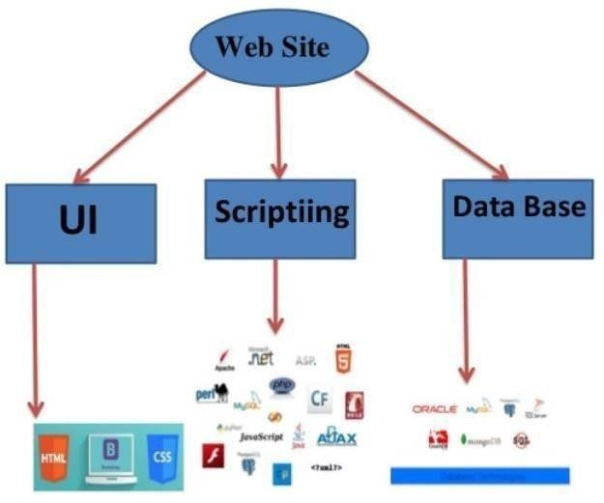

**Figure 1:Website Description**

### TECHNOLOGIES

Technologies that are used to develop A website are:

* + HTML
  + CSS
  + Bootstrap.
  + JavaScript
  + Django

### Introduction to HTML

HTML Hypertext Markup Language (HTML) is the standard markup language for creating web pages and web applications. With Cascading Style Sheets (CSS) and JavaScript it forms a triad of cornerstone technologies for the World Wide Web. Web browsers receive HTML documents from a webserver or from local storage and render them into multimedia web pages. HTML describes the structure of a web page semantically and originally included cues for the appearance of the document.

HTML elements are the building blocks of HTML pages. With HTML constructs, images and other objects, such as interactive forms, may be embedded into the rendered page. It

provides a means to create structured documents by denoting structural semantics for text such as headings, paragraphs, lists, links, quotes and other items.

HTML elements are delineated by tags, written using angle brackets. Tags such as

<img /> and <input /> introduce content into the page directly. Others such as

<p>...</p> surround and provide information about document text and may include other tags as sub-elements. Browsers do not display the HTML tags, but use them to interpret the content of the page.

HTML can embed programs written in a scripting language such as JavaScript which affect the behaviour and content of web pages. Inclusion of CSS defines the look and layout of content. The World Wide Web Consortium (W3C), maintainer of both the HTML and the CSS standards, has encouraged the use of CSS over explicit presentational HTML since 1997.

HTML markup consists of several key components, including those called tags (and their attributes), character-based data types, character references and entity references. HTML tags most commonly come in pairs like <h1> and </h1>, although some represent empty elements and so are unpaired, for example <img>. The first tag in such a pair is the start tag, and the second is the end tag (they are also called opening tags and closing tags).

The following is an example of the classic Hello world program, a common test employed for comparing programming languages, scripting languages and markup languages. This example is made using 9 lines of code:

#### GENERAL SYNTAX OF HTML:

*<!DOCTYPE html>*

*<html>*

*<head>*

*<title>This is a title</title>*

*</head> <body>*

*<p>Hello world!</p>*

*</body>*

*</html>*

(The text between <html> and </html> describes the web page, and the text between

<body> and </body> is the visible page content. The markup text "<title>This is a title</title>" defines the browser page title.)

The Document Type Declaration <!DOCTYPE html> is for HTML5. If a declaration is not included, various browsers will revert to "quirks mode" for rendering.

### Introduction to CSS

CSS Cascading Style Sheets (CSS) is a style sheet language used for describing the presentation of a document written in a markup language. Although most often used to set the visual style of web pages and user interfaces written in HTML and XHTML, the language can be applied to any XML document, including plain XML, SVG and XUL, and is applicable to rendering in speech, or on other media. Along with HTML and JavaScript, CSS is a cornerstone technology used by most websites to create visually engaging webpages, user interfaces for web applications, and user interfaces for many mobile applications.

CSS is designed primarily to enable the separation of presentation and content, including aspects such as the layout, colors, and fonts. This separation can improve content accessibility, provide more flexibility and control in the specification of presentation characteristics, enable multiple HTML pages to share formatting by specifying the relevant CSS in a separate .css file, and reduce complexity and repetition in the structural content.

Separation of formatting and content makes it possible to present the same markup page in different styles for different rendering methods, such as on-screen, in print, by voice (via speech-based browser or screen reader), and on Braille-based tactile devices. It can also display the web page differently depending on the screen size or viewing device. Readers can also specify a different style sheet, such as a CSS file stored on their own computer, to override the one the author specified.

Changes to the graphic design of a document (or hundreds of documents) can be applied quickly and easily, by editing a few lines in the CSS file they use, rather than by changing markup in the documents.

The CSS specification describes a priority scheme to determine which style rules apply if more than one rule matches against a particular element. In this so-called

cascade, priorities (or weights) are calculated and assigned to rules, so that the results are predictable. The CSS specifications are maintained by the World Wide Web Consortium (W3C). Internet media type (MIME type) text/css is registered for use with CSS by RFC 2318 (March 1998). The W3C operates a free CSS validation service for CSS documents.

#### TYPES OF CSS :

* **Inline CSS:** In this CSS is applied in between the tags. E.g.:

*<tag style =” styling” > Hello World </tag>*

* **Internal CSS:** In this the css code is defined inside the style tag in the head section of the HTML page. General Syntax: *<html>*

*<head> <style> <! -- CSS STYLING -- >*

*</style>*

*</head>*

*</html>*

* **External CSS:** In this the CSS code is written on another page and is linked to the HTML page. It is advantageous to use this type of styling as we can use the same file to style various HTML pages. External CSS uses the extension .css and is applied using the following syntax: *<html>*

*<head>*

*<link relation=” stylesheet” type=”css” href=”URL to the page”>*

*</head>*

*</html>*

All the CSS style types are important but can be used in different situations.

* **Inline CSS** is used when only small changes are to be done to the HTML tag and the changes are to be reflected only to that specific tag
* **Internal CSS** is used when the individual HTML pages have to be designed differently. This also slows the page load system if the internal styling is long.
* **External CSS** files are maintained to design multiple pages and use common styles over various pages. It is useful as it helps in managing the resources in an easy manner.

Both HTML and CSS are used to create a UI but CSS behaves like a makeup on the face of an actress which makes her look even more beautiful than she is in reality, and here is the difference.

**Page With CSS**

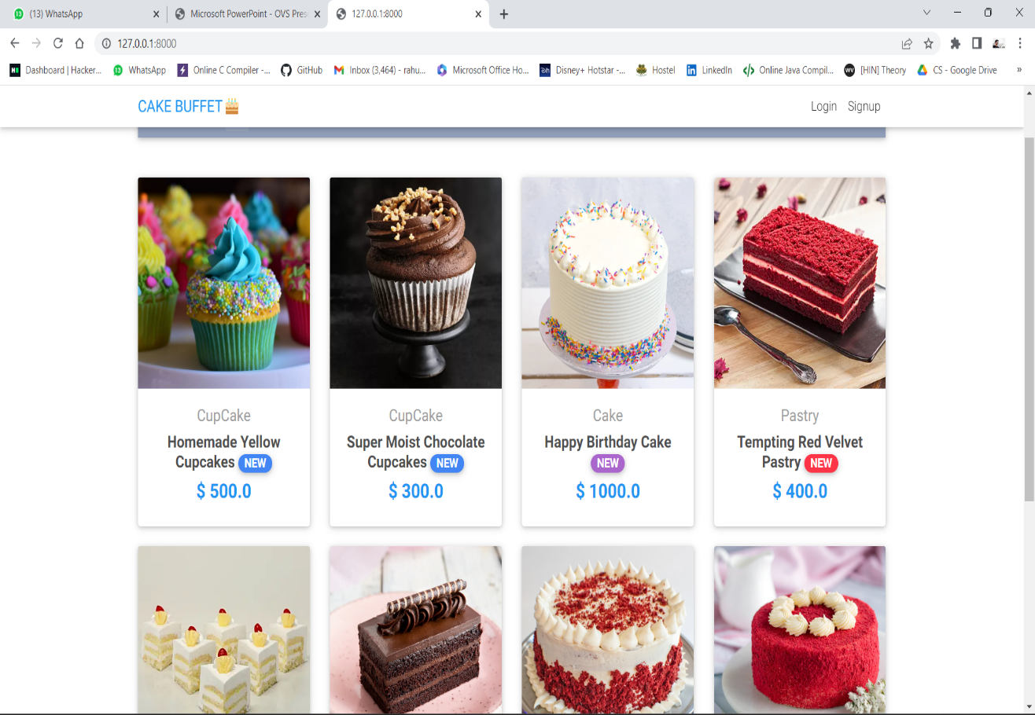

### Introduction to BOOTSTRAP

Bootstrap is a free and open-source front-end web framework for designing websites and web applications. It contains HTML- and CSS-based design templates for typography, forms, buttons, navigation and other interface components, as well as optional JavaScript extensions. Unlike many web frameworks, it concerns itself with front-end development only.

Bootstrap is the second most-starred project on GitHub, with more than 107,000 stars and 48,000 forks.

Bootstrap, originally named Twitter Blueprint, was developed by Mark Otto and Jacob Thornton at Twitter as a framework to encourage consistency across internal tools. Before Bootstrap, various libraries were used for interface development, which led to inconsistencies and a high maintenance burden. According to twitter developer Mark Otto:

“A super small group of developers and I got together to design and build a new internal tool and saw an opportunity to do something more. Through that process, we saw ourselves build something much more substantial than another internal tool. Months later, we ended up with an early version of Bootstrap as a way to document and share common design patterns and assets with in the company.

After a few months of development by a small group, many developers at Twitter began to contribute to the project as a part of Hack Week, a hackathon-style week for the Twitter development team. It was renamed from Twitter Blueprint to Bootstrap, and released as an open source project on August 19, 2011. It has continued to be maintained by Mark Otto, Jacob Thornton, and a small group of core developers, as well as a large community of contributors.

On January 31, 2012, Bootstrap 2 was released, which added a twelve-column responsive grid layout system, inbuilt support for Glyphicons, several new components, as well as changes to many of the existing components.

On August 19, 2013, Bootstrap 3 was released, which redesigned components to use flat design, and a mobile first approach.

11

On October 29, 2014, Mark Otto announced that Bootstrap 4 was in development. The first alpha version of Bootstrap 4 was released on August 19, 2015.

Bootstrap 3 supports the latest versions of the Google Chrome, Firefox, Internet Explorer, Opera, and Safari (except on Windows). It additionally supports back to IE8 and the latest Firefox Extended Support Release (ESR).

Since 2.0, Bootstrap supports responsive web design. This means the layout of web pages adjusts dynamically, taking into account the characteristics of the device used (desktop, tablet, mobile phone).

Starting with version 3.0, Bootstrap adopted a mobile-first design philosophy, emphasizing responsive design by default. The version 4.0 alpha release added Sass and flexbox support.

#### INSTALLING AND LINKING BOOTSTRAP:

* + Install bootstrap from https://getbootstrap.com/

➢

Copy the bootstrap.min.css file to your CSS folder and link it to the HTML page in the similar manner to how any other CSS file is linked.

## ➢

Link the bootstrap.min.js file which is present in the JS folder of the bootstrap. It can be linked using script tag. E.g.:

*<script src=”URL to bootstrap.min.js”></script>*

Now use bootstrap classes to reduce the work of designing which was earlier done through CSS.

### PROJECT: TOUR INDIA

#### OBJECTIVE: “CAKE BUFFET” is the online website where users can find their favourite destinations to travel with their friends and family, in this project we tried to describe the famous places to visit in India and their best pakages.

TECHNOLOGIES USED:

* + CSS
  + BOOTSTRAP
  + JavaScript
  + HTML

### Overall Description

#### DESCRIPTION:

* Any one can visit website and can choose cake
* There are many delicious cake which can attract users
* If they are interested, then they can signup their and can provide their details to us.

#### How to view website or code:

Wesite: <https://harsh-si14.github.io/tour-travel/> Code: <https://harsh-si14.github.io/tour-travel/>

#### WEB PAGE DETAILS:

 Home Page

 About us

 Signup Page (to provide us details)

 Order summary

 Login

### CAKE BUFFET

. “CAKE BUFFET” is an online Cake Order is a web based application which enable customers to order cakes through web online. • As the internet users are increasing rapidly, online customize cake ordering system will help the customers to order the cake as per their choice.

#### HOME PAGE:

###### Home Page

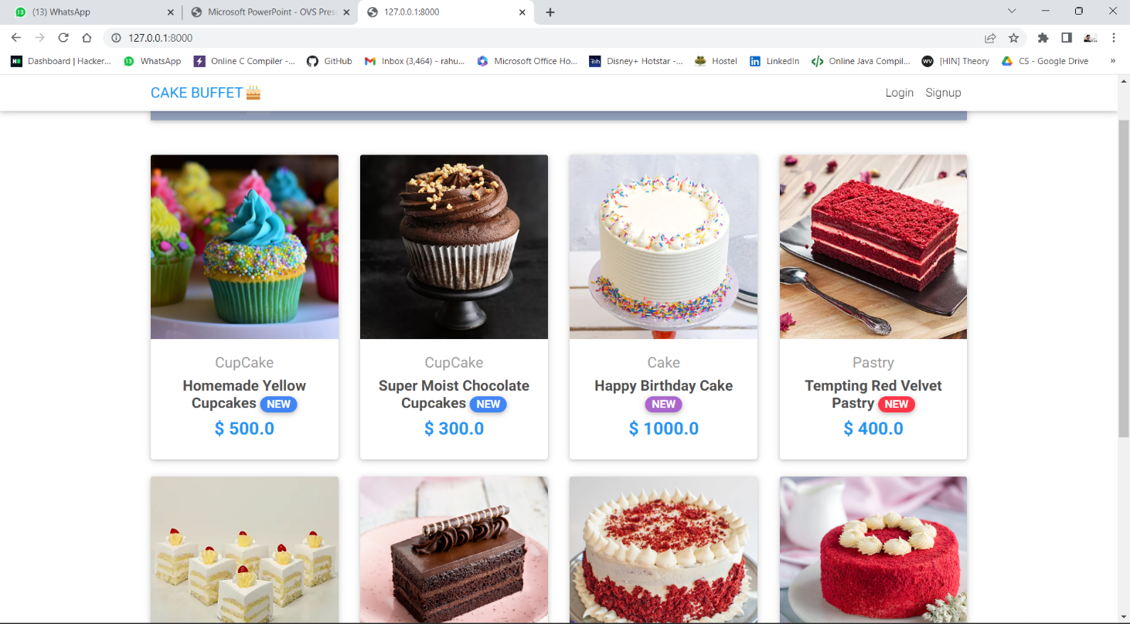

**About Us:**

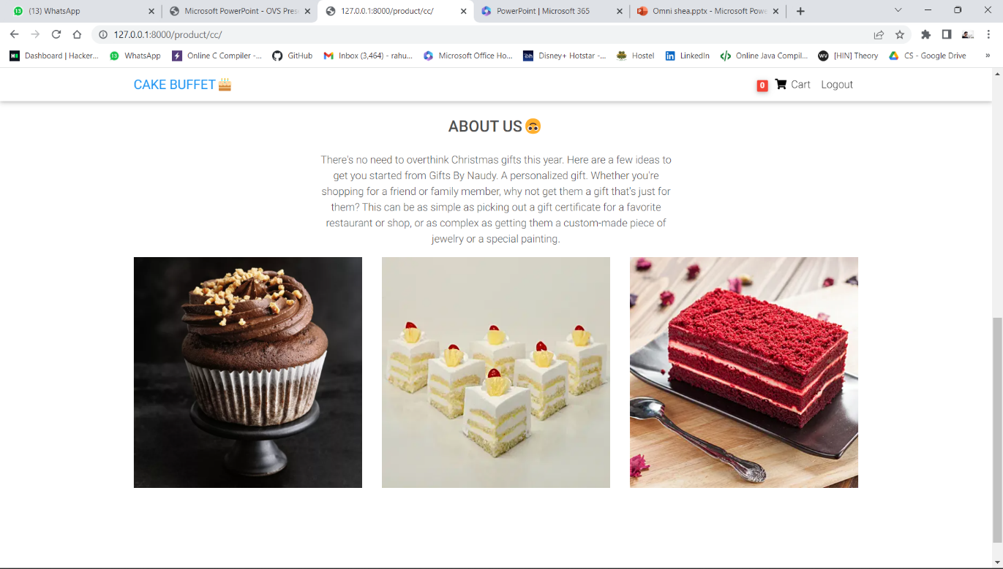**:**

**Signup Page:**

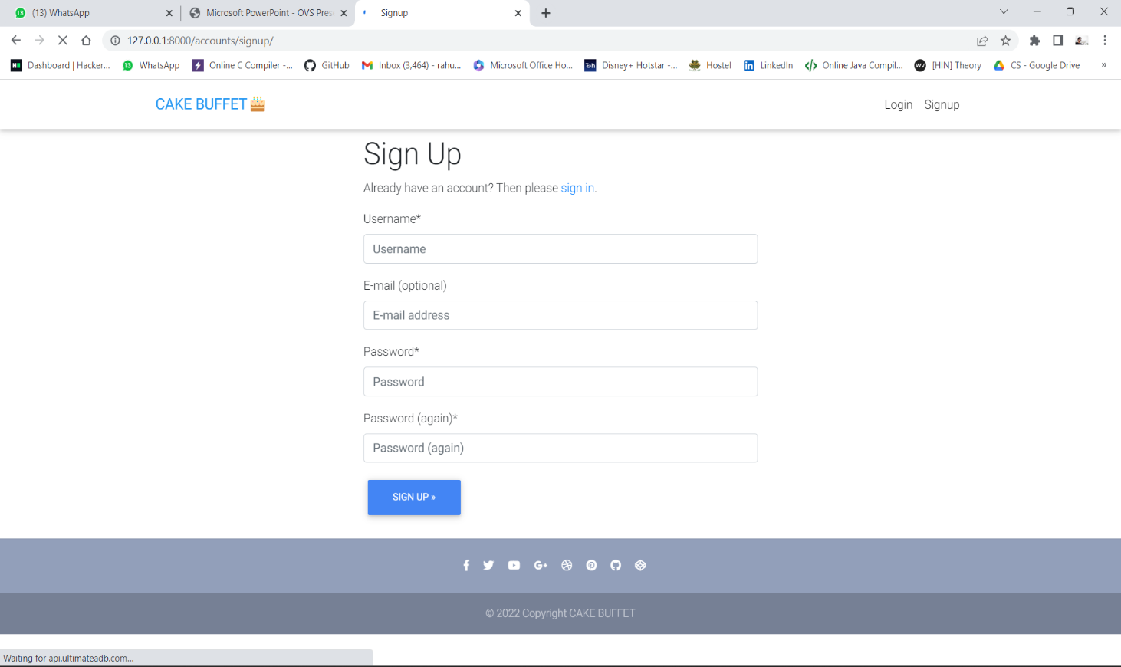

**Order Summary:**

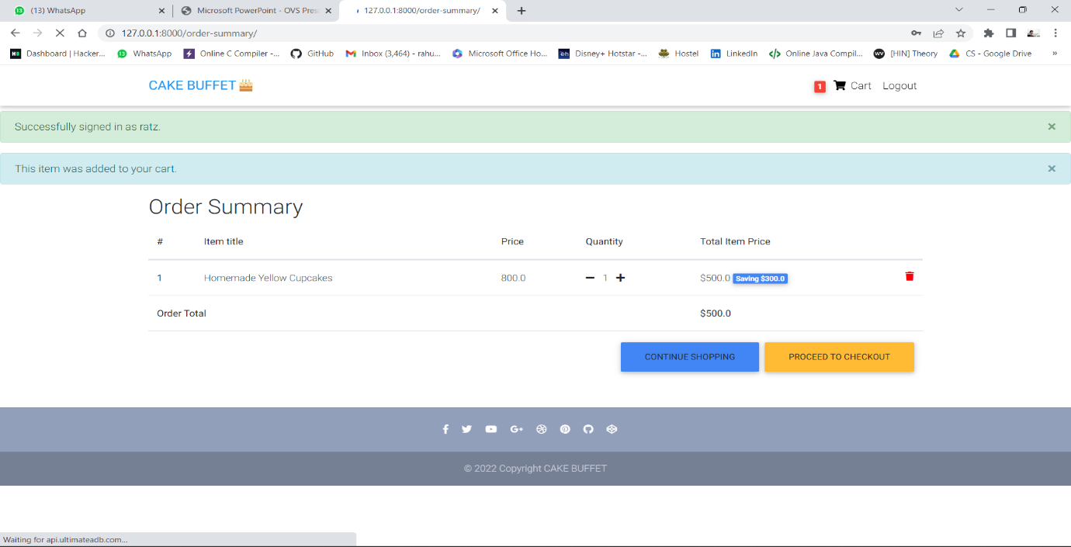

**Login page:** 